ASSIGNMENT 3

Question1:

Created a class named employee with name, family, salary and department and created a constructor and initialized name, family, salary, and department. Created a data member named no_of_employees to count the employees. Created a function named average_salary to calculate the average salary and a sub class full_time_employee, a sub class of employee.

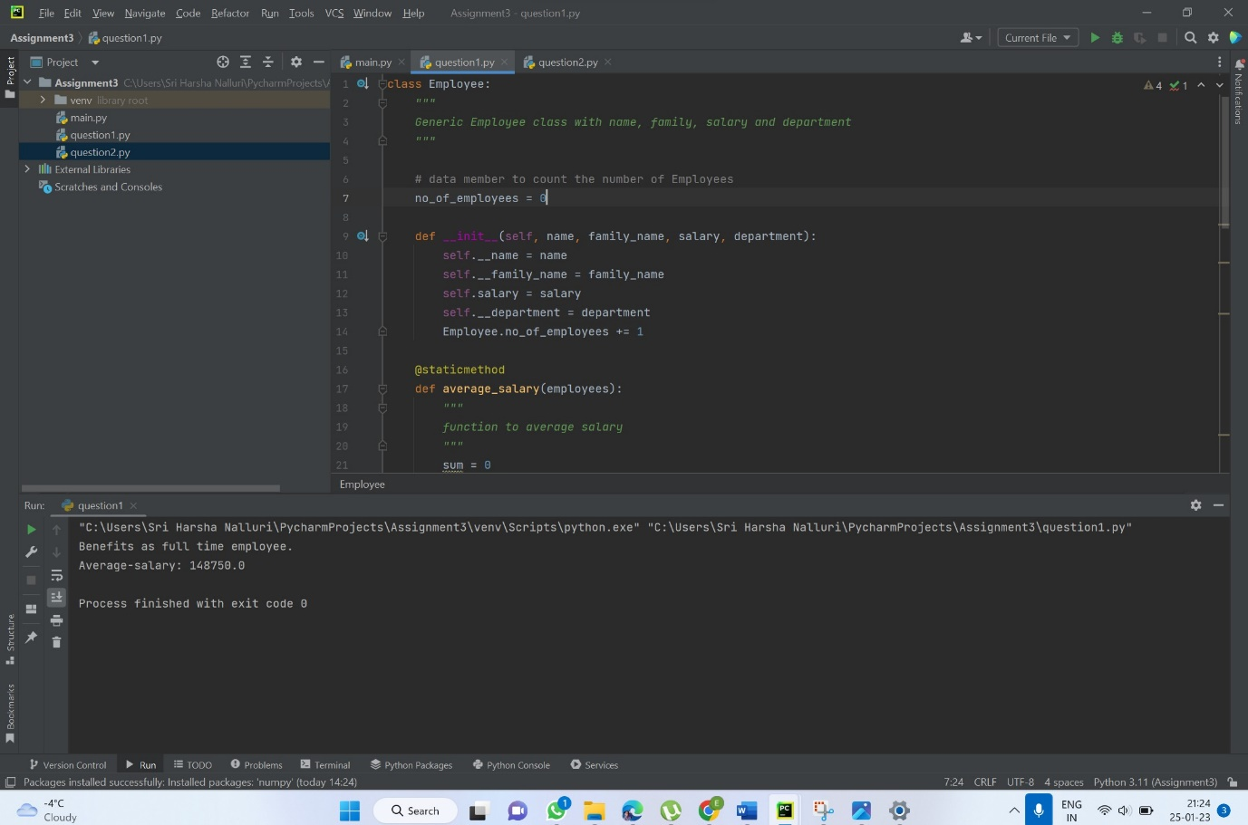

Question2:

Created a random vector of size 20 having only float in the range 1-20 using numpy, reshaped the array to 4 by 5 using reshape function, and replaced maximum with 0 and printed it.

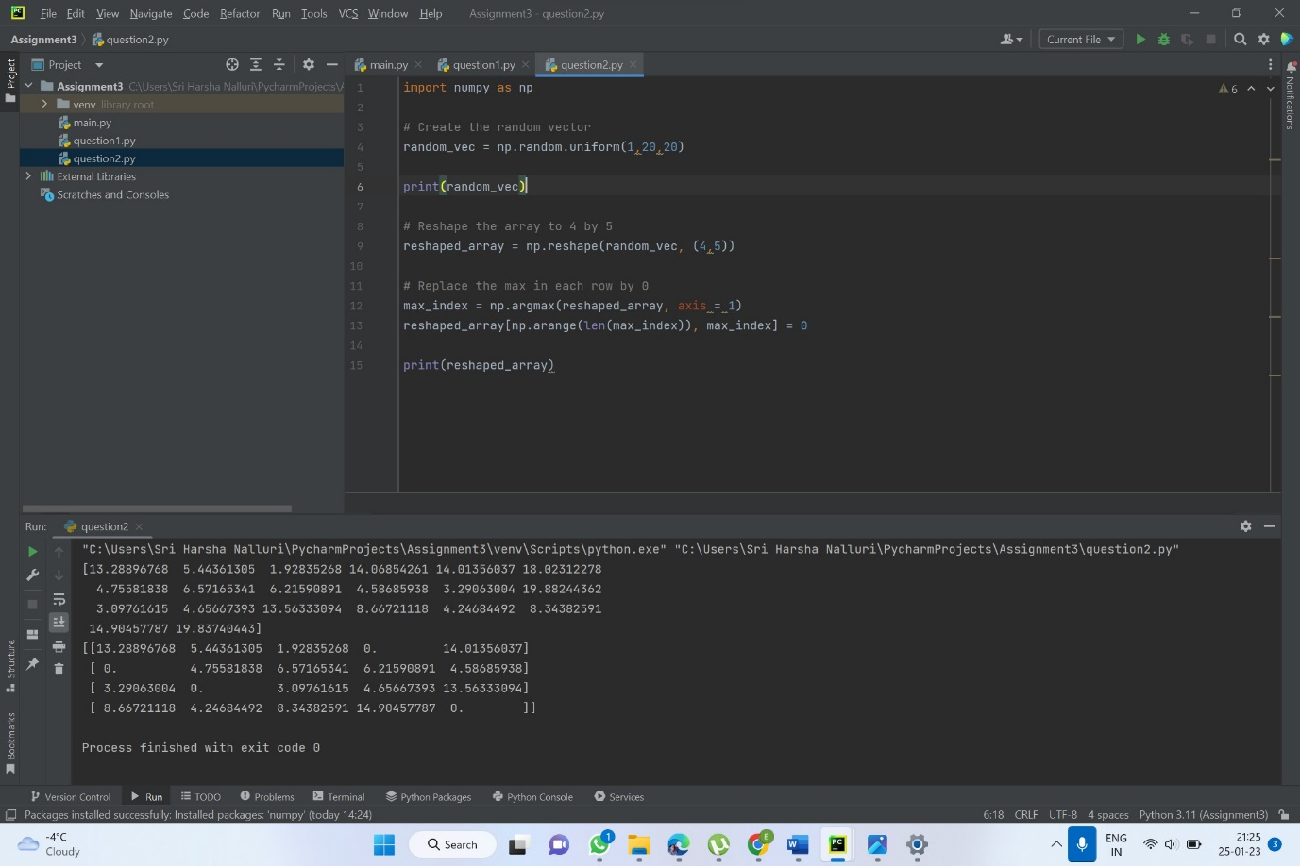

Video link:

<https://drive.google.com/file/d/1-RZ1PZoz4wx8Bb-aeH3ag4oYz4xHYzx6/view?usp=sharing>